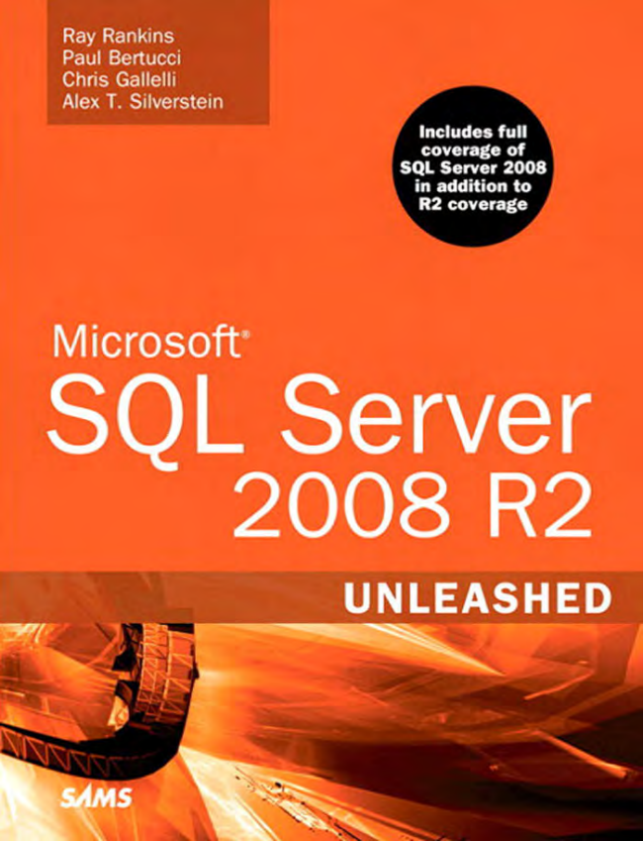

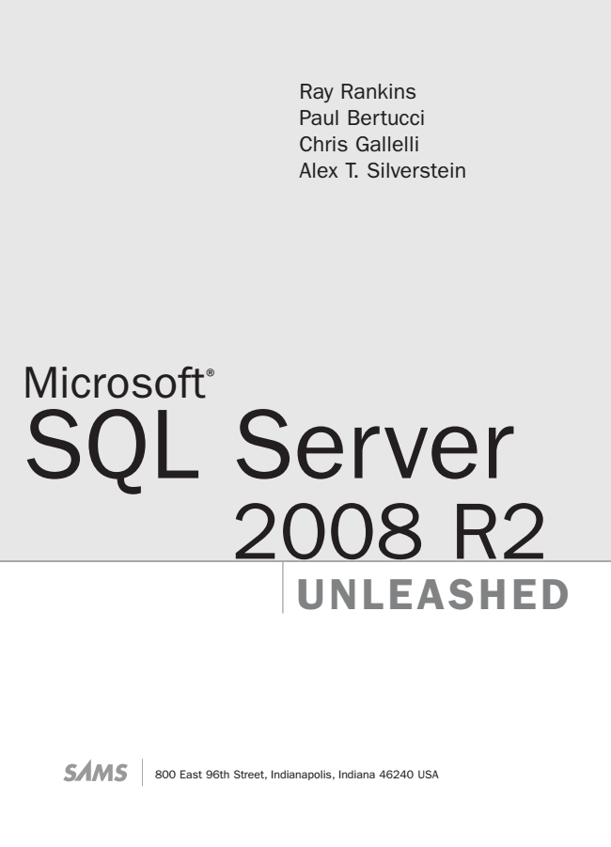

Ray Rankins Paul Bertucci Chris Gallelli Alex T. Silverstein

Microsoft

® SQL Server

2008 R2

UNLEASHED

800 East 96th Street, Indianapolis, Indiana 46240 USA

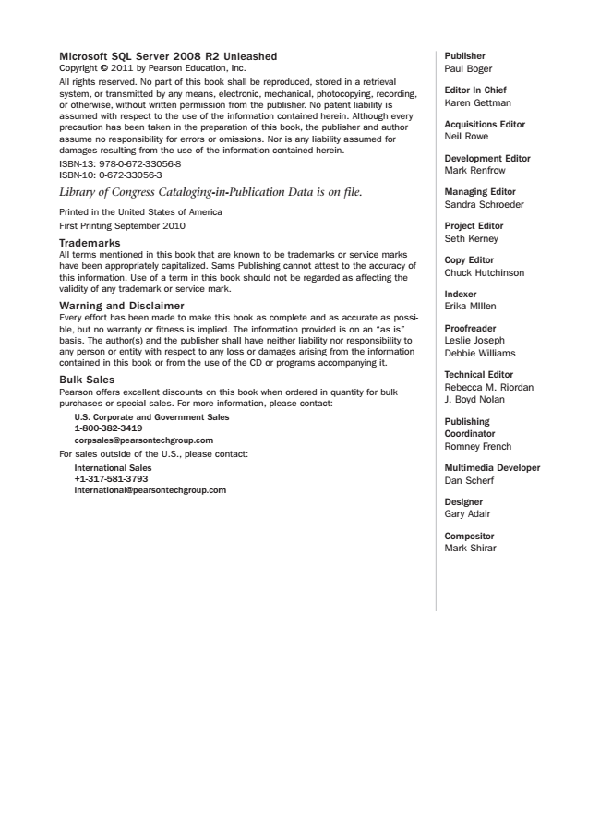

Microsoft SQL Server 2008 R2 Unleashed Copyright © 2011 by Pearson Education, Inc. All rights reserved. No part of this book shall be reproduced, stored in a retrieval system, or transmitted by any means, electronic, mechanical, photocopying, recording, or otherwise, without written permission from the publisher. No patent liability is assumed with respect to the use of the information contained herein. Although every precaution has been taken in the preparation of this book, the publisher and author assume no responsibility for errors or omissions. Nor is any liability assumed for damages resulting from the use of the information contained herein. ISBN-13: 978-0-672-33056-8 ISBN-10: 0-672-33056-3 Library of Congress Cataloging-in-Publication Data is on file.

Printed in the United States of America First Printing September 2010 Trademarks All terms mentioned in this book that are known to be trademarks or service marks have been appropriately capitalized. Sams Publishing cannot attest to the accuracy of this information. Use of a term in this book should not be regarded as affecting the validity of any trademark or service mark. Warning and Disclaimer Every effort has been made to make this book as complete and as accurate as possi- ble, but no warranty or fitness is implied. The information provided is on an “as is” basis. The author(s) and the publisher shall have neither liability nor responsibility to any person or entity with respect to any loss or damages arising from the information contained in this book or from the use of the CD or programs accompanying it. Bulk Sales Pearson offers excellent discounts on this book when ordered in quantity for bulk purchases or special sales. For more information, please contact:

U.S. Corporate and Government Sales 1-800-382-3419 corpsales@pearsontechgroup.com For sales outside of the U.S., please contact:

International Sales +1-317-581-3793 international@pearsontechgroup.com

Publisher Paul Boger

Editor In Chief Karen Gettman

Acquisitions Editor Neil Rowe

Development Editor Mark Renfrow

Managing Editor Sandra Schroeder

Project Editor Seth Kerney

Copy Editor Chuck Hutchinson

Indexer Erika MIllen

Proofreader Leslie Joseph Debbie Williams

Technical Editor Rebecca M. Riordan J. Boyd Nolan

Publishing Coordinator Romney French

Multimedia Developer Dan Scherf

Designer Gary Adair

Compositor Mark Shirar

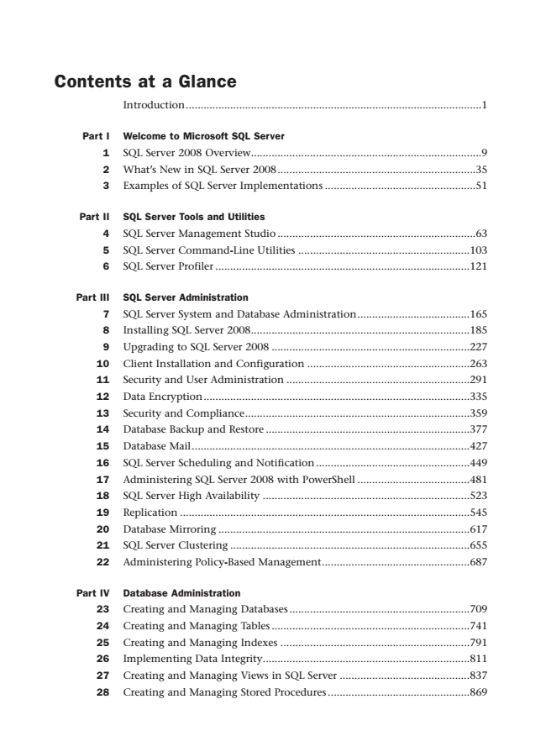

Contents at a Glance

Introduction....................................................................................................1

Part I Welcome to Microsoft SQL Server

1 SQL Server 2008 Overview..............................................................................9 2 What’s New in SQL Server 2008...................................................................35 3 Examples of SQL Server Implementations ...................................................51

Part II SQL Server Tools and Utilities

4 SQL Server Management Studio ...................................................................63 5 SQL Server Command-Line Utilities ..........................................................103 6 SQL Server Profiler ......................................................................................121

Part III SQL Server Administration

7 SQL Server System and Database Administration......................................165 8 Installing SQL Server 2008..........................................................................185 9 Upgrading to SQL Server 2008 ...................................................................227 10 Client Installation and Configuration .......................................................263 11 Security and User Administration ..............................................................291 12 Data Encryption..........................................................................................335 13 Security and Compliance............................................................................359 14 Database Backup and Restore .....................................................................377 15 Database Mail..............................................................................................427 16 SQL Server Scheduling and Notification....................................................449 17 Administering SQL Server 2008 with PowerShell ......................................481 18 SQL Server High Availability ......................................................................523 19 Replication ..................................................................................................545 20 Database Mirroring .....................................................................................617 21 SQL Server Clustering .................................................................................655 22 Administering Policy-Based Management..................................................687

Part IV Database Administration

23 Creating and Managing Databases .............................................................709 24 Creating and Managing Tables ...................................................................741 25 Creating and Managing Indexes ................................................................791 26 Implementing Data Integrity......................................................................811 27 Creating and Managing Views in SQL Server ............................................837 28 Creating and Managing Stored Procedures ................................................869

Download from www.wowebook.com

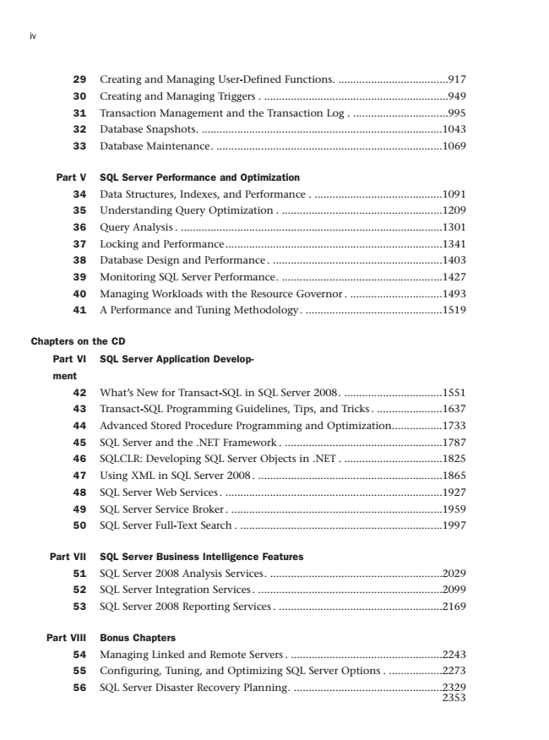

iv

29 Creating and Managing User-Defined Functions. .....................................917 30 Creating and Managing Triggers . ..............................................................949 31 Transaction Management and the Transaction Log . ................................995 32 Database Snapshots. .................................................................................1043 33 Database Maintenance. ............................................................................1069

Part V SQL Server Performance and Optimization

34 Data Structures, Indexes, and Performance . ...........................................1091 35 Understanding Query Optimization . ......................................................1209 36 Query Analysis . ........................................................................................1301 37 Locking and Performance.........................................................................1341 38 Database Design and Performance . .........................................................1403 39 Monitoring SQL Server Performance. ......................................................1427 40 Managing Workloads with the Resource Governor . ...............................1493 41 A Performance and Tuning Methodology. ..............................................1519

Chapters on the CD

Part VI SQL Server Application Develop-

ment

42 What’s New for Transact-SQL in SQL Server 2008. .................................1551 43 Transact-SQL Programming Guidelines, Tips, and Tricks . ......................1637 44 Advanced Stored Procedure Programming and Optimization.................1733 45 SQL Server and the .NET Framework . .....................................................1787 46 SQLCLR: Developing SQL Server Objects in .NET . .................................1825 47 Using XML in SQL Server 2008 . ..............................................................1865 48 SQL Server Web Services . .........................................................................1927 49 SQL Server Service Broker . .......................................................................1959 50 SQL Server Full-Text Search . ....................................................................1997

Part VII SQL Server Business Intelligence Features

51 SQL Server 2008 Analysis Services. ..........................................................2029 52 SQL Server Integration Services . ..............................................................2099 53 SQL Server 2008 Reporting Services . .......................................................2169

Part VIII Bonus Chapters

54 Managing Linked and Remote Servers . ...................................................2243 55 Configuring, Tuning, and Optimizing SQL Server Options . ..................2273 56 SQL Server Disaster Recovery Planning. ..................................................2329

Index

Download from www.wowebook.com

2353

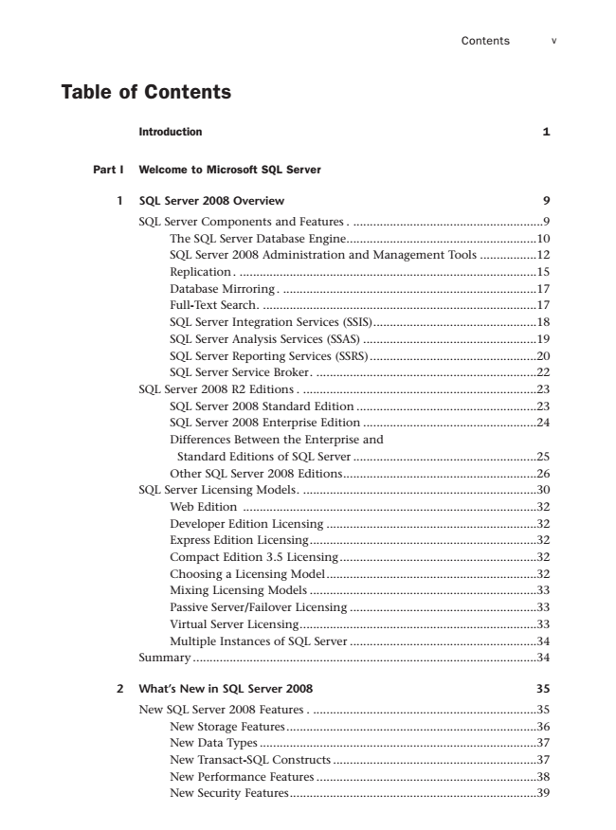

Contents v

Table of Contents

Introduction 1

Part I Welcome to Microsoft SQL Server

**1 SQL Server 2008 Overview 9**

SQL Server Components and Features . .........................................................9 The SQL Server Database Engine.........................................................10 SQL Server 2008 Administration and Management Tools .................12 Replication . .........................................................................................15 Database Mirroring . ............................................................................17 Full-Text Search. ..................................................................................17 SQL Server Integration Services (SSIS).................................................18 SQL Server Analysis Services (SSAS) ....................................................19 SQL Server Reporting Services (SSRS)..................................................20 SQL Server Service Broker. ..................................................................22 SQL Server 2008 R2 Editions . ......................................................................23 SQL Server 2008 Standard Edition ......................................................23 SQL Server 2008 Enterprise Edition ....................................................24 Differences Between the Enterprise and

Standard Editions of SQL Server .......................................................25 Other SQL Server 2008 Editions..........................................................26 SQL Server Licensing Models. ......................................................................30 Web Edition ........................................................................................32 Developer Edition Licensing ...............................................................32 Express Edition Licensing....................................................................32 Compact Edition 3.5 Licensing...........................................................32 Choosing a Licensing Model...............................................................32 Mixing Licensing Models ....................................................................33 Passive Server/Failover Licensing ........................................................33 Virtual Server Licensing.......................................................................33 Multiple Instances of SQL Server ........................................................34 Summary .......................................................................................................34

**2 What’s New in SQL Server 2008 35**

New SQL Server 2008 Features . ...................................................................35 New Storage Features...........................................................................36 New Data Types ...................................................................................37 New Transact-SQL Constructs .............................................................37 New Performance Features ..................................................................38 New Security Features..........................................................................39

Download from www.wowebook.com

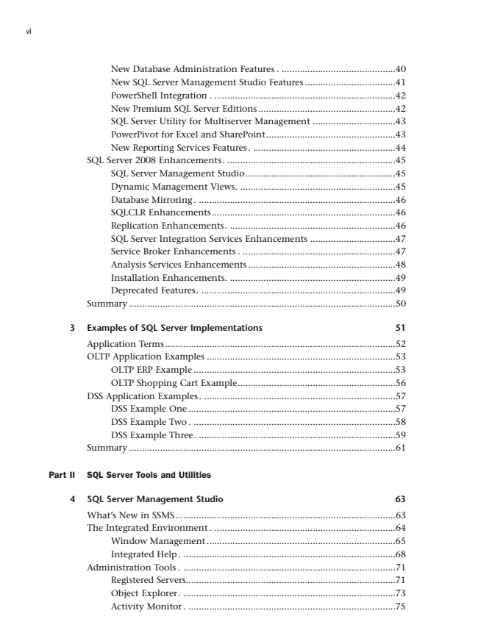

vi

New Database Administration Features . ............................................40 New SQL Server Management Studio Features ...................................41 PowerShell Integration . ......................................................................42 New Premium SQL Server Editions .....................................................42 SQL Server Utility for Multiserver Management ................................43 PowerPivot for Excel and SharePoint..................................................43 New Reporting Services Features. .......................................................44 SQL Server 2008 Enhancements. .................................................................45 SQL Server Management Studio..........................................................45 Dynamic Management Views. ............................................................45 Database Mirroring. ............................................................................46 SQLCLR Enhancements.......................................................................46 Replication Enhancements. ................................................................46 SQL Server Integration Services Enhancements .................................47 Service Broker Enhancements . ...........................................................47 Analysis Services Enhancements .........................................................48 Installation Enhancements. ................................................................49 Deprecated Features. ...........................................................................49 Summary .......................................................................................................50

**3 Examples of SQL Server Implementations 51**

Application Terms.........................................................................................52 OLTP Application Examples .........................................................................53 OLTP ERP Example ..............................................................................53 OLTP Shopping Cart Example.............................................................56 DSS Application Examples. ..........................................................................57 DSS Example One ................................................................................57 DSS Example Two . ..............................................................................58 DSS Example Three. ............................................................................59 Summary .......................................................................................................61

Part II SQL Server Tools and Utilities

**4 SQL Server Management Studio 63**

What’s New in SSMS.....................................................................................63 The Integrated Environment . ......................................................................64 Window Management .........................................................................65 Integrated Help. ..................................................................................68 Administration Tools . ..................................................................................71 Registered Servers.................................................................................71 Object Explorer. ..................................................................................73 Activity Monitor . ................................................................................75

Download from www.wowebook.com

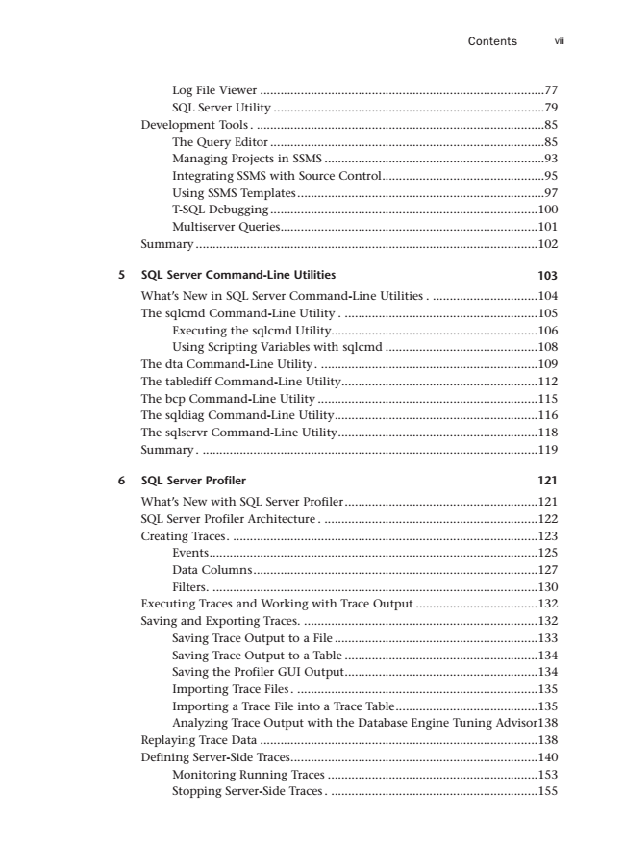

Contents vii

Log File Viewer ....................................................................................77 SQL Server Utility ................................................................................79 Development Tools . .....................................................................................85 The Query Editor .................................................................................85 Managing Projects in SSMS .................................................................93 Integrating SSMS with Source Control................................................95 Using SSMS Templates.........................................................................97 T-SQL Debugging ...............................................................................100 Multiserver Queries............................................................................101 Summary .....................................................................................................102

**5 SQL Server Command-Line Utilities 103**

What’s New in SQL Server Command-Line Utilities . ...............................104 The sqlcmd Command-Line Utility . .........................................................105 Executing the sqlcmd Utility.............................................................106 Using Scripting Variables with sqlcmd .............................................108 The dta Command-Line Utility. ................................................................109 The tablediff Command-Line Utility..........................................................112 The bcp Command-Line Utility .................................................................115 The sqldiag Command-Line Utility............................................................116 The sqlservr Command-Line Utility...........................................................118 Summary . ...................................................................................................119

**6 SQL Server Profiler 121**

What’s New with SQL Server Profiler.........................................................121 SQL Server Profiler Architecture . ...............................................................122 Creating Traces. ..........................................................................................123 Events.................................................................................................125 Data Columns....................................................................................127 Filters. ................................................................................................130 Executing Traces and Working with Trace Output ....................................132 Saving and Exporting Traces. .....................................................................132 Saving Trace Output to a File ............................................................133 Saving Trace Output to a Table .........................................................134 Saving the Profiler GUI Output.........................................................134 Importing Trace Files . .......................................................................135 Importing a Trace File into a Trace Table..........................................135 Analyzing Trace Output with the Database Engine Tuning Advisor138 Replaying Trace Data ..................................................................................138 Defining Server-Side Traces.........................................................................140 Monitoring Running Traces ..............................................................153 Stopping Server-Side Traces . .............................................................155

Download from www.wowebook.com

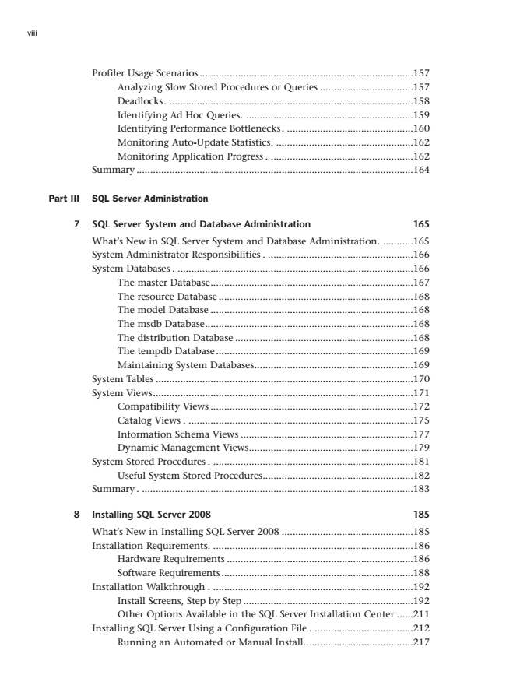

viii

Profiler Usage Scenarios ..............................................................................157 Analyzing Slow Stored Procedures or Queries ..................................157 Deadlocks. .........................................................................................158 Identifying Ad Hoc Queries. .............................................................159 Identifying Performance Bottlenecks. ..............................................160 Monitoring Auto-Update Statistics. ..................................................162 Monitoring Application Progress . ....................................................162 Summary .....................................................................................................164

Part III SQL Server Administration

**7 SQL Server System and Database Administration 165**

What’s New in SQL Server System and Database Administration. ...........165 System Administrator Responsibilities . .....................................................166 System Databases . ......................................................................................166 The master Database..........................................................................167 The resource Database .......................................................................168 The model Database ..........................................................................168 The msdb Database............................................................................168 The distribution Database .................................................................168 The tempdb Database........................................................................169 Maintaining System Databases..........................................................169 System Tables ..............................................................................................170 System Views...............................................................................................171 Compatibility Views ..........................................................................172 Catalog Views . ..................................................................................175 Information Schema Views ...............................................................177 Dynamic Management Views............................................................179 System Stored Procedures . .........................................................................181 Useful System Stored Procedures.......................................................182 Summary . ...................................................................................................183

**8 Installing SQL Server 2008 185**

What’s New in Installing SQL Server 2008 ................................................185 Installation Requirements. .........................................................................186 Hardware Requirements ....................................................................186 Software Requirements ......................................................................188 Installation Walkthrough . .........................................................................192 Install Screens, Step by Step ..............................................................192 Other Options Available in the SQL Server Installation Center ......211 Installing SQL Server Using a Configuration File . ....................................212 Running an Automated or Manual Install........................................217

Download from www.wowebook.com

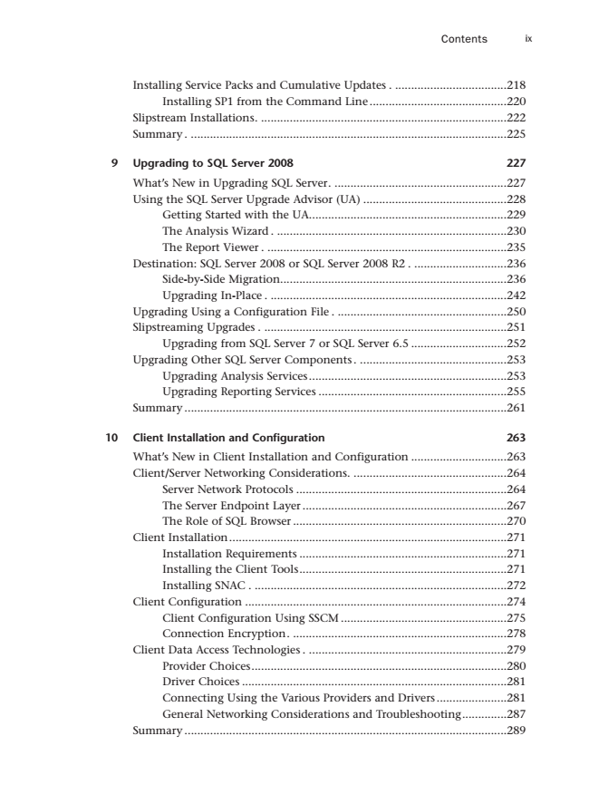

Contents ix

Installing Service Packs and Cumulative Updates . ...................................218 Installing SP1 from the Command Line ...........................................220 Slipstream Installations. .............................................................................222 Summary . ...................................................................................................225

**9 Upgrading to SQL Server 2008 227**

What’s New in Upgrading SQL Server. ......................................................227 Using the SQL Server Upgrade Advisor (UA) .............................................228 Getting Started with the UA..............................................................229 The Analysis Wizard . ........................................................................230 The Report Viewer . ...........................................................................235 Destination: SQL Server 2008 or SQL Server 2008 R2 . .............................236 Side-by-Side Migration.......................................................................236 Upgrading In-Place . ..........................................................................242 Upgrading Using a Configuration File . .....................................................250 Slipstreaming Upgrades . ............................................................................251 Upgrading from SQL Server 7 or SQL Server 6.5 ..............................252 Upgrading Other SQL Server Components . ..............................................253 Upgrading Analysis Services..............................................................253 Upgrading Reporting Services ...........................................................255 Summary .....................................................................................................261

**10 Client Installation and Configuration 263**

What’s New in Client Installation and Configuration ..............................263 Client/Server Networking Considerations. ................................................264 Server Network Protocols ..................................................................264 The Server Endpoint Layer ................................................................267 The Role of SQL Browser ...................................................................270 Client Installation.......................................................................................271 Installation Requirements .................................................................271 Installing the Client Tools.................................................................271 Installing SNAC . ...............................................................................272 Client Configuration ..................................................................................274 Client Configuration Using SSCM ....................................................275 Connection Encryption. ...................................................................278 Client Data Access Technologies . ..............................................................279 Provider Choices................................................................................280 Driver Choices ...................................................................................281 Connecting Using the Various Providers and Drivers ......................281 General Networking Considerations and Troubleshooting..............287 Summary .....................................................................................................289

Download from www.wowebook.com